Database Management Systems Lab Work

Practical 7:

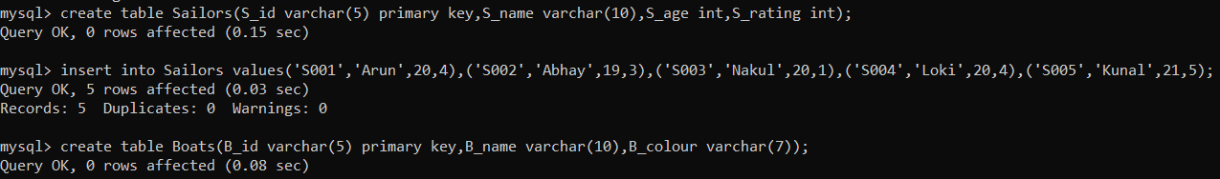





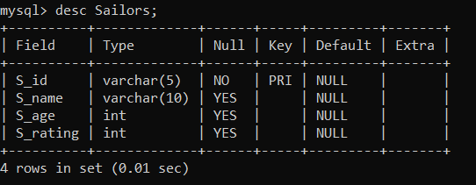

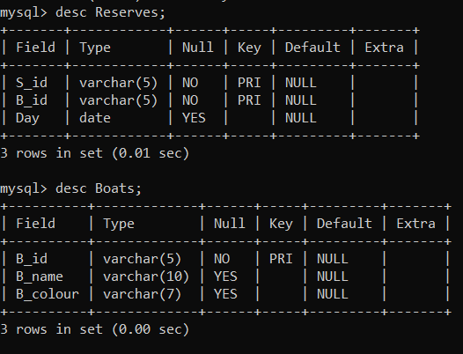

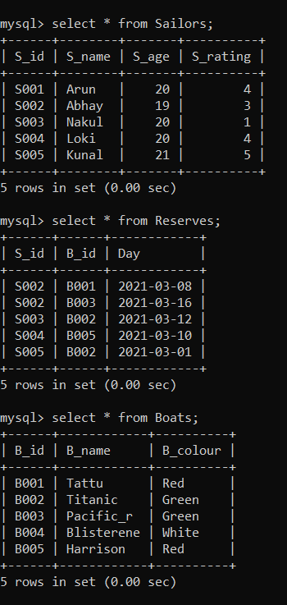

1. Find the S_id of the Sailors who have reserved red boat but not green boat.



2. Find the S_id of the Sailors who have reserved red boat or green boat.

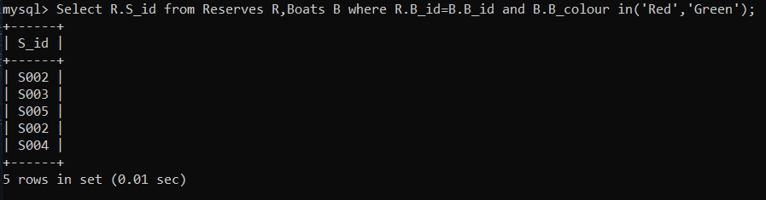

3. Find the S_id of the sailors who have reserved both red boat and green boat.



Practical 8:

**Using Natural Join:**

1.Find names of sailors who have reserved boat number B003.

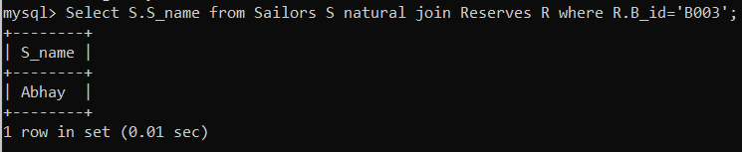

2.Find names of sailors who have reserved at least one boat.

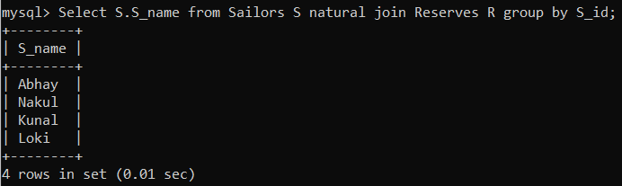

3.Find names of sailors who have reserved a red boat.

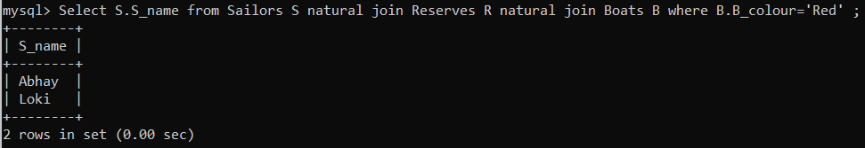

4.Find the colours of boat reserved by Abhay.

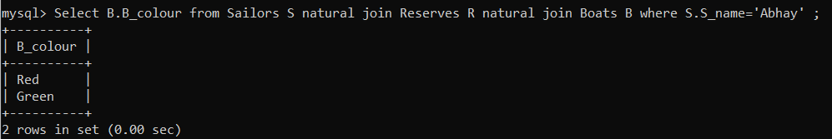

**Using Equi Join:**

5. Find names of sailors who have reserved boat number B003.

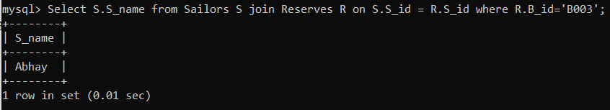

6.Find names of sailors who have reserved at least one boat.

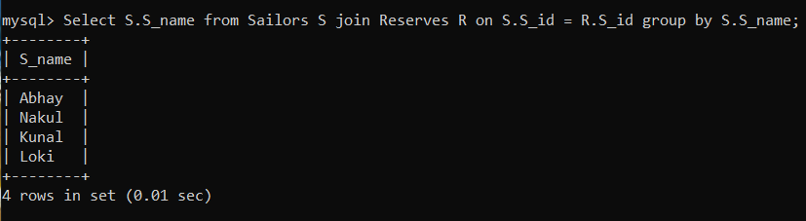

7.Find names of sailors who have reserved a red boat.

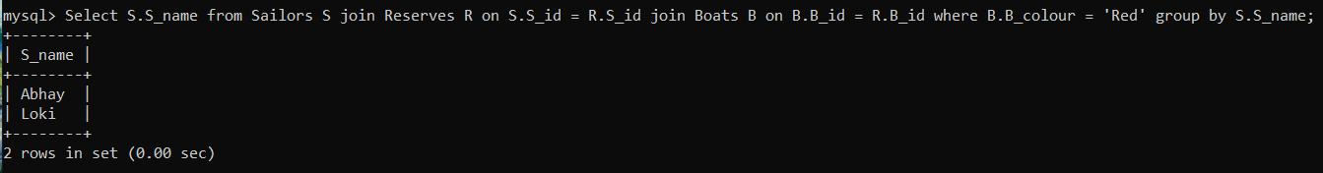

8.Find the colours of boat reserved by Abhay.

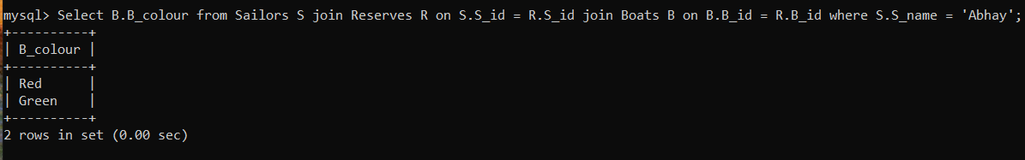

**Nested Queries:**

9.Find the sailors whose rating is better than some sailor called Abhay.

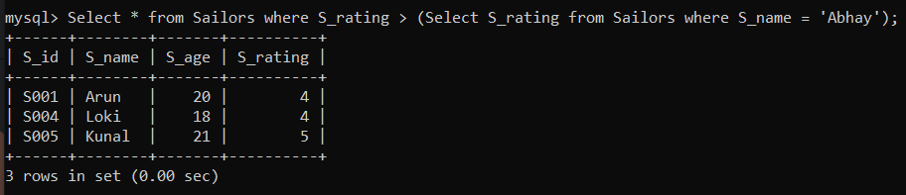

10.

11.Find the sailor with highest rating.

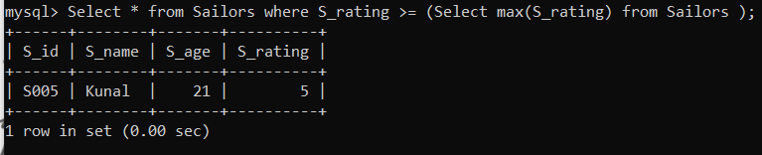

**Self Join:**

1.Create a table Employees (Emp_no, Name, Manager_no) where Emp_no is the primary key and Manager_no is the foreign key.

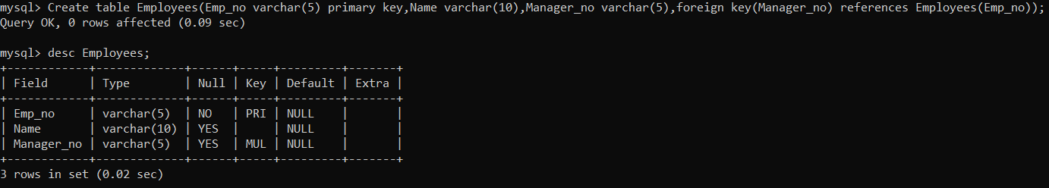

2.Insert following rows:

|  |  |  |
| --- | --- | --- |
| Emp_no | Name | Manager_no |
| E01 | Basu | E02 |
| E02 | Rukmani | E05 |
| E03 | Carol | E04 |
| E04 | Bayross | NULL |
| E05 | Ivan | NULL |

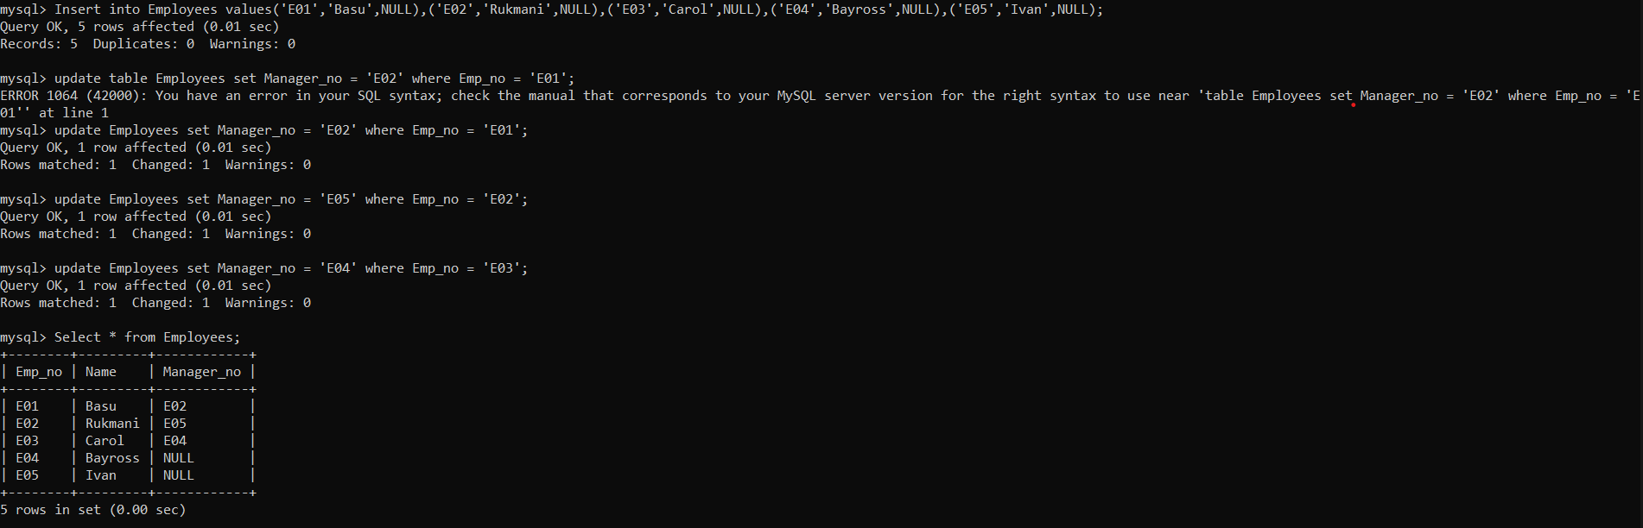

3.Execute a query to retrieve names of the employees and the name of their respective managers from the employee table.

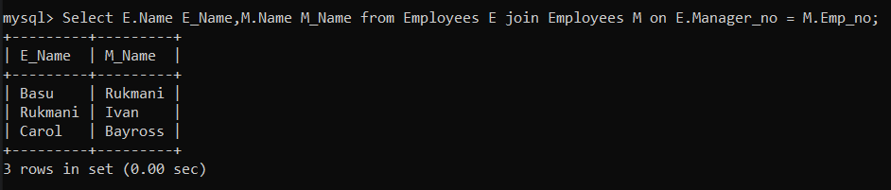

**Outer Join:**

1.Create tables and insert these rows:

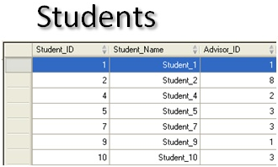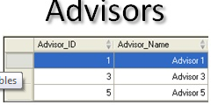

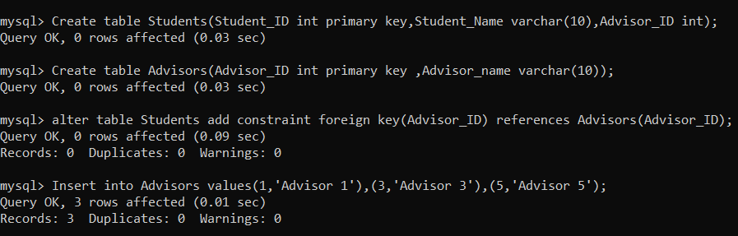

2.Query for retrieving the student details along with their advisory detail.

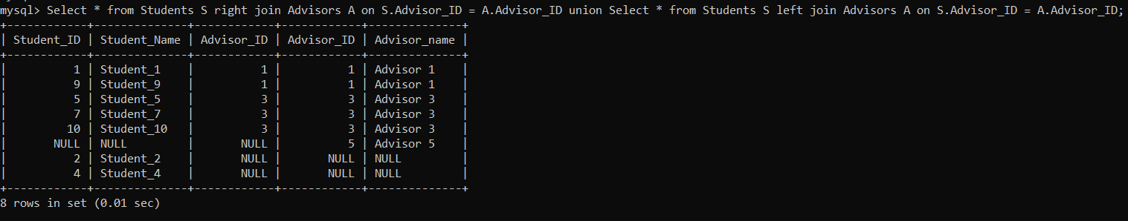

3.Query for retrieving the details of all the student along with details of advisory (using outer join).

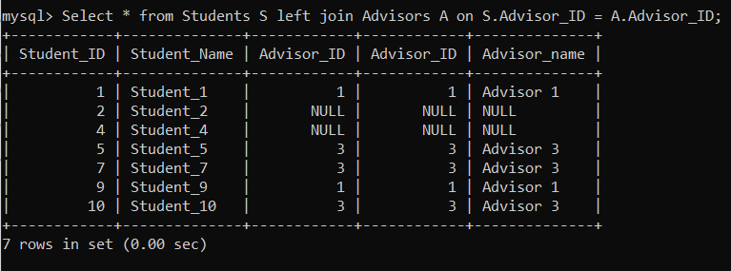

4.Query for retrieving the details of student along with details of all the advisory (using outer join).

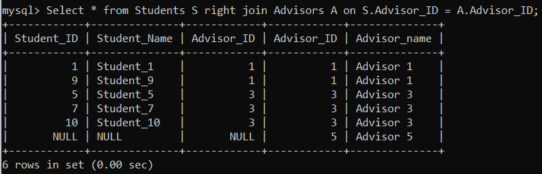

Practical 9:

1.Find the age of youngest sailors for each rating level.

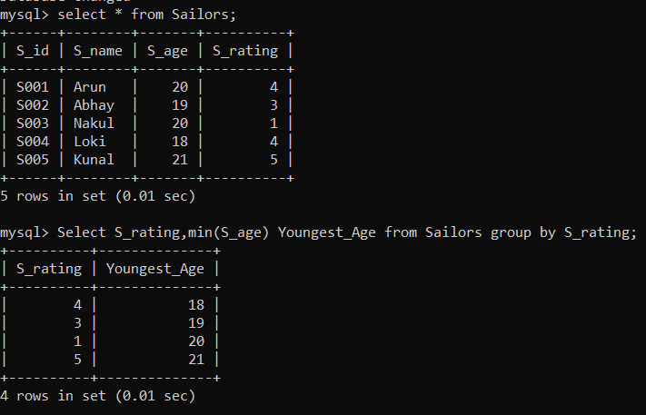

2.Find the age of youngest sailor who is eligible to vote for each rating level with at least two such Sailor.

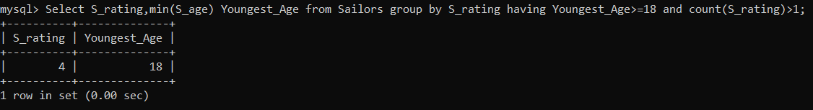

3. For each red boat, find the number of reservations for this Boat.

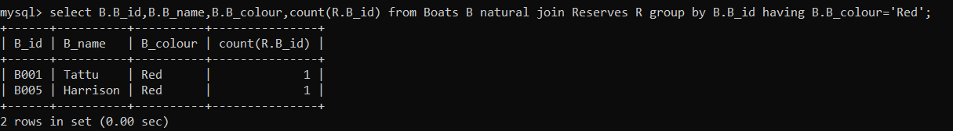

4.Find average age of sailor for each rating level that has at least two such sailors.

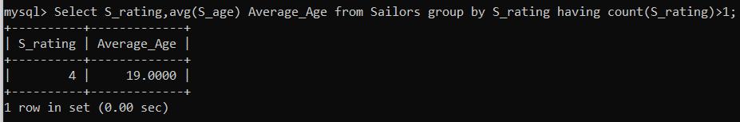

5.Write a query to print the following sentence:

Sailor named ………. with sailor id………. has reserved boat number………...on date…………….

